St. Michael and All Angels | 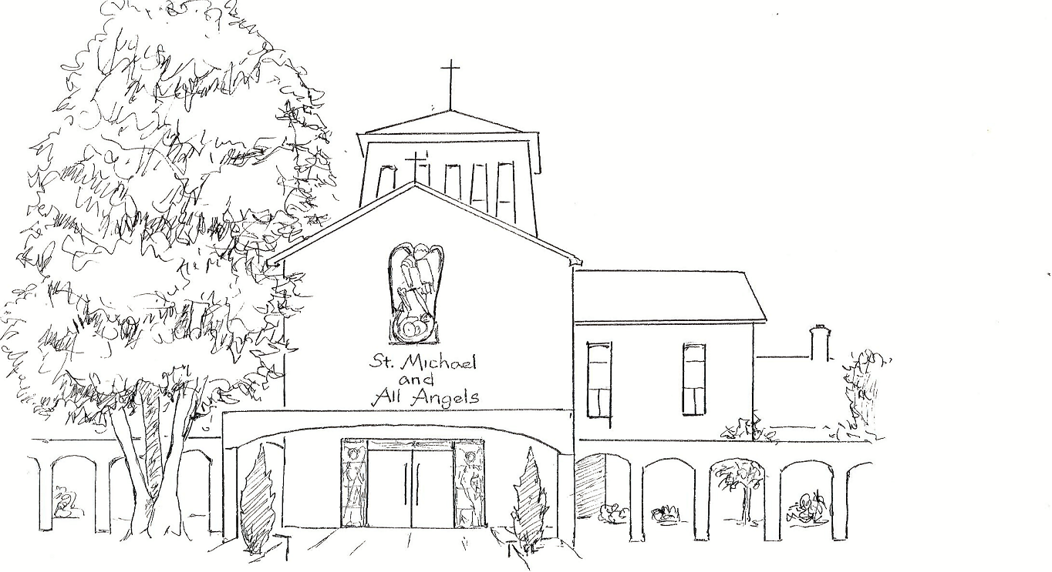 | Amersham on the Hill



HOLY HEALING EUCHARIST

Said Service

Eucharists with Healing are held nine times a year at St Michael’s across the weekday and Sunday services. They are special times of reflection, restoration and wholeness, especially when one is busy or stressed.



During today’s service, there will be “laying on of hands” by a commissioned member of St. Michael’s Healing Team, whose hands will lightly rest on each person’s head as this, or a similar prayer, is quietly spoken:

“May the healing power of God - Father, Son and Holy Spirit - fill you with his peace and meet you today at your point of need in body, mind and spirit.
In the name of Jesus Christ, our Lord. Amen.”

Following the laying on of hands, a priest will anoint with oil blessed specially for healing and wholeness, making the sign of the cross on each person’s forehead and hands as this, or a similar prayer, is quietly spoken:

“I anoint you in the name of the Father who loves you, the Son who redeems you, and the Spirit who gives you life.”



Laying on of hands and anointing are practices which date back to the very early church and are mentioned many times in the Bible. They are offered at today’s service but are not imposed. For some, the sacramental healing of the Eucharist alone may be preferred, and this option is always available.

Greeting and Welcome Please stand, if able

The Lord be with you
And also with you.

Let us be still in God’s presence.
Love and be loved.
Fall deep into silence:
the silence of God.

We keep a time of silence.

Prayer of Invocation

We prepare a place for you.
Come to us in the difference of every life gathered.
Come to us in word.
Come to us in stillness.
Come to us in bread and wine.
Come to us in flesh and blood.
Reach out across time.
Be present in all time.
Come Jesus, be our guest,
stay with us this day/night,
with friend and stranger,
with young and old,
with the lost and found.
Be among us this day/night
our guest, our host,
the one who says all - all are welcome here.

Prayer of Penitence

The sun of righteousness has dawned
with healing in his wings.
Let us come to the light of Christ,
confessing our sins in penitence and faith.

Please sit or kneel.
God our Father, we confess the times
when we have looked away from you;
Lord, have mercy.
Lord, have mercy.

Jesus our friend, forgive us
when we have focused only on ourselves;
Christ, have mercy.
Christ, have mercy.

Holy Spirit, our life-giver, we are sorry
when we have caused separation and hurt;
Lord, have mercy.
Lord, have mercy.

We turn to you now for forgiveness and healing.

Absolution

May the God of love and power,
forgive you and free you from your sins,
heal and strengthen you by his Spirit,
and raise you to new life in Christ our Lord.
Amen.

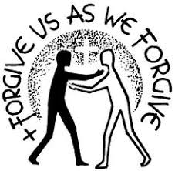

The Collect (printed on notices)

Gospel Reading Please turn to face the Gospel.

The Lord be with you
And also with you.

Hear the Gospel of our Lord Jesus Christ according to …..

Glory to you, O Lord.



At the end
This is the Gospel of the Lord.
Praise to you, O Christ.

Please sit.

Sermon

Please stand, if able.
Affirmation of Faith

Let us declare our faith in God.

We believe in God the Father,
from whom every family
in heaven and on earth is named.

We believe in God the Son,
who lives in our hearts through faith,
and fills us with his love.

We believe in God the Holy Spirit,
who strengthens us
with power from on high.

We believe in one God;
Father, Son and Holy Spirit.

Amen.

Please sit or kneel.

Prayers of Intercession

This response may be used:

Lord, in your mercy
Hear our prayer.

And at the end:

Merciful Father,
accept these prayers for the sake of your Son,
our Saviour Jesus Christ. Amen.

The Peace

God of eternal peace, who offers the gift of peace and whose children are the peace makers;
pour your peace into our hearts,
that conflict and anger may cease.

The peace of the Lord be always with you.
And also with you.

Let us offer one another a sign of peace.

All may exchange a sign of peace.

Preparation of the Table

The table is prepared and bread and wine are placed upon it.
The gifts of the people are gathered and presented.

Lord Jesus Christ,
you have invited us to come to this your table.
We have come from many places and experiences;
we have come with all our differences;
we have come to the place where journeys meet.
You have reached out to all on the edge
and called us into the heart of God.

The Eucharistic Prayer

The Lord is here.
His Spirit is with us.

Lift up your hearts.
We lift them to the Lord.

Let us give thanks to the Lord our God.
It is right to give thanks and praise.
It is right to praise you, Father, Lord of all creation;
in your love you made us for yourself.
When we turned away
you did not reject us,
but came to meet us in your Son.
You embraced us as your children
and welcomed us to sit and eat with you.

In Christ you shared our life
that we might live in him and he in us.
He opened his arms of love upon the cross
and made for all the perfect sacrifice for sin.

On the night he was betrayed,
at supper with his friends
he took bread, and gave you thanks;
he broke it and gave it to them, saying:
Take, eat; this is my body which is given for you;
do this in remembrance of me.

Pause while the president elevates the bread

Father, we do this in remembrance of him:
his body is the bread of life.

At the end of supper, taking the cup of wine,
he gave you thanks, and said:
Drink this, all of you; this is my blood of the new covenant,
which is shed for you for the forgiveness of sins;
Do this in remembrance of me.

Pause while the president elevates the cup

Father, we do this in remembrance of him:
His blood is shed for all.

As we proclaim his death and celebrate his rising in glory,
send your Holy Spirit that this bread and this wine
may be to us the body and blood of your dear Son.

As we eat and drink these holy gifts
make us one in Christ, our risen Lord.

With your whole Church throughout the world
we offer you this sacrifice of praise
and lift our voice to join the eternal song of heaven:

Holy, holy, holy Lord,
God of power and might,
heaven and earth are full of your glory.
Hosanna in the highest.
Blessed is he who comes in the name of the Lord.
Hosanna in the highest.

Please sit or kneel.

The Lord’s Prayer

As our Saviour taught us, so we pray:

Our Father in heaven,
hallowed be your name,
your kingdom come,
your will be done,
on earth as in heaven.
Give us today our daily bread.
Forgive us our sins
as we forgive those who sin against us.
Lead us not into temptation
but deliver us from evil.
For the kingdom, the power,
and the glory are yours now and for ever.
Amen.

Breaking of the Bread

Look, Jesus Christ, the Bread of Heaven,

is broken for the life of the world.
The gifts of God for the people of God.
Jesus, Bread of Life
Bread for the world.
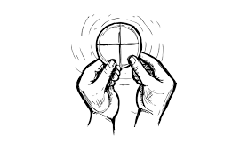
Jesus, Lamb of God,
have mercy on us.

Jesus, bearer of our sins,
have mercy on us.

Jesus, redeemer of the world,
grant us peace.

Giving of Communion

Jesus is the Lamb of God
who takes away the sin of the world.
Blessed are those who are called to his supper.
Lord, I am not worthy to receive you,
but only say the word, and I shall be healed.

Prayers for healing and anointing follow on if so desired.

Prayer of Thanksgiving

God of hope, in bread and wine you have restored us to relationship with you.
Show us how to be a people that live your reconciling love in the world, so that we may recognise your presence in those we meet, and our hearts like those first disciples may burn within us upon the road.
Lord Jesus Christ,
You are the Word for us to speak,
You are the Truth for us to tell;
You are the Light for us to light in the darkness,
You are the Bread of Life for us to share.
Amen.

Blessing

Now all of us must go out into the world
and live God’s love there.
Look for Jesus in the oppressed and burdened.
Look for Jesus in those who have lost hope.
Look for him among the poor in heart,
among the merciful, among the peacemakers,
among the persecuted for the sake of right.
Look for Jesus on the edge.
And the blessing of God Almighty,
Father, Son and Holy Spirit be with you and all those whom you love, where ever they may be, now and for all eternity.
Amen.

The Dismissal

Go simply, lightly, gently.
Go with obedience.
Go with love.
Go in the peace of Christ.
Amen.



Acknowledgements:

Common Worship: Services and Prayers for the Church of England and New Patterns for Worship, material from which is included in this service, are copyright © The Archbishops’ Council 2000 and 2002. CCL Noo 908682,Enriching the Christian Year (1993),
Invitation to Confession – NPFW – B24
Absolution – NPFW – B80
Liturgy on the Edge, pastoral and attractional worship: Canterbury Press. Edited Samuel West. 2018
St M & AA 2019

