St. Michael and All Angels | 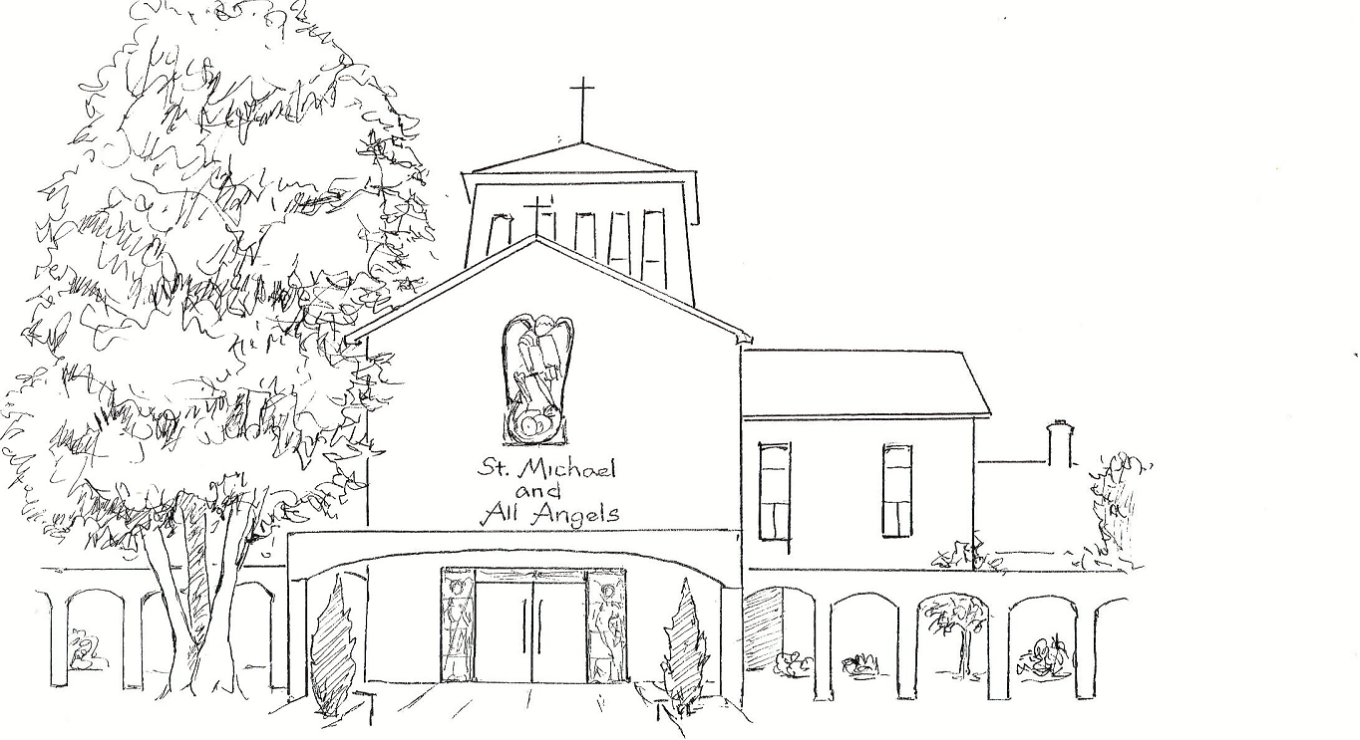 | Amersham on the Hill



HOLY EUCHARIST
ORDINARY TIME

A warm welcome to this service
This booklet is designed for use throughout Ordinary Time and includes guidance notes. Do please ask a “Welcomer” if you need any further help.

“Ordinary Time” is those parts of the liturgical year when no other season is observed, namely from the day following the Presentation of Christ (Candlemas) to Shrove Tuesday, and again from the Monday following the Day of Pentecost until the Saturday before the First Sunday of Advent.

There is, though, nothing “ordinary” about Ordinary Time, which simply comes from the word “ordinal”, meaning “counted time”, (as Sundays are numbered “before Lent” or “after Trinity”).

The seasonal colour is green, denoting new life and growth, and the trefoil shown above is a seasonal symbol dating back to Celtic Christian times, with its continuous line forming three sections to denote God who is three-in-one, Father, Son and Holy Spirit.

The Gathering

Introit

Processional Hymn Please stand, if able.

The Greeting

The Lord be with you
All and also with you.
Please sit.
Words of welcome or introduction may be said.

Prayer of Preparation

All Almighty God,
to whom all hearts are open,
all desires known,
and from whom no secrets are hidden:
cleanse the thoughts of our hearts
by the inspiration of your Holy Spirit,
that we may perfectly love you,
and worthily magnify your holy name;
through Christ our Lord.
Amen.

Prayers of Penitence

Deacon Our Lord Jesus Christ said:
The first commandment is this:
“Hear, O Israel, the Lord our God is the only Lord.
You shall love the Lord your God with all your heart,
with all your soul, with all your mind,
and with all your strength.”

The second is this: “Love your neighbour as yourself.”
There is no other commandment greater than these.
On these two commandments hang all the law and the prophets.

All Amen. Lord, have mercy.

Invitation to Confession

My brothers and sisters,
as we prepare to celebrate the presence of Christ in word and sacrament,
let us call to mind and confess our sins.

Please remain seated or kneel.
We pause for confession.

Confession

All Father eternal, giver of light and grace,
we have sinned against you and against our neighbour,
in what we have thought,
In what we have said and done,
through ignorance, through weakness,
through our own deliberate fault.
We have wounded your love,
And marred your image in us.
We are sorry and ashamed,
and repent of all our sins.
For the sake of your Son Jesus Christ,
who died for us,
forgive us all that is past
and lead us out from darkness
to walk as children of light.
Amen.

or

All Most merciful God,
Father of our Lord Jesus Christ,
we confess that we have sinned
in thought, word and deed.
We have not loved you with our whole heart.
We have not loved our neighbours as ourselves.
In your mercy
forgive what we have been,
help us to amend what we are,
and direct what we shall be;
that we may do justly,
love mercy,
and walk humbly with you, our God.
Amen.
Absolution

President May almighty God, have mercy on you,
forgive you your sins,
and bring you to ever lasting life.
All Amen.
Please stand, if able.
Gloria in Excelsis

All Glory to God in the highest,
and peace to his people on earth.

Lord God, heavenly King,
almighty God and Father,
we worship you, we give you thanks,
we praise you for your glory.

Lord Jesus Christ, only Son of the Father,
Lord God, Lamb of God,
you take away the sin of the world:
have mercy on us;
you are seated at the right hand of the Father:
receive our prayer.

For you alone are the Holy One,
you alone are the Lord,
you alone are the Most High, Jesus Christ,
with the Holy Spirit,
in the glory of God the Father.
Amen.

The Collect
The priest gathers together, or collects, our prayers.

The Liturgy of the Word Please sit.
(Readings and Psalm on Notice Sheet)

Old Testament Reading

For the word of the Lord
All Thanks be to God.

Psalm
Choir – all sing responses.

New Testament Reading

For the word of the Lord
All Thanks be to God.

Gradual Hymn Please stand, if able.

Gospel Reading Please turn to face the Gospel.

Alleluia, alleluia.
Speak, Lord, for your servant is listening.
You have the words of eternal life.
Alleluia, alleluia. (1 Samuel 3.9; John 6.68)

or

Alleluia, alleluia.
We do not live by bread alone,
but by every word that comes from the mouth of God.
Alleluia, alleluia. (cf Matthew 4.4)

The Lord be with you
All and also with you.

Hear the Gospel of our Lord Jesus Christ according to N.
All Glory to you, O Lord.

The Gospel is proclaimed.

This is the Gospel of the Lord.
All Praise to you, O Christ.

Sermon

Affirmation of Faith Please stand, if able.

Let us declare our faith in God.

All We believe in God the Father,
from whom every family
in heaven and on earth is named.

We believe in God the Son,
who lives in our hearts through faith,
and fills us with his love.

We believe in God the Holy Spirit,
who strengthens us
with power from on high.

We believe in one God;
Father, Son and Holy Spirit.
Amen. (cf Ephesians 3)

or

All We believe in one God,
the Father, the Almighty,
maker of heaven and earth,
of all that is,
seen and unseen.

We believe in one Lord, Jesus Christ,
the only Son of God,
eternally begotten of the Father,
God from God, Light from Light,
true God from true God,
begotten, not made,
of one Being with the Father;
through him all things were made.
For us and for our salvation he came down from heaven,
was incarnate from the Holy Spirit and the Virgin Mary
and was made man.
For our sake he was crucified under Pontius Pilate;
he suffered death and was buried.
On the third day he rose again
in accordance with the Scriptures;
he ascended into heaven
and is seated at the right hand of the Father.
He will come again in glory to judge the living and the dead,
and his kingdom will have no end.

We believe in the Holy Spirit,
the Lord, the giver of life,
who proceeds from the Father and the Son,
who with the Father and the Son is worshipped and glorified,
who has spoken through the prophets.
We believe in one holy catholic and apostolic Church.
We acknowledge one baptism for the forgiveness of sins.
We look for the resurrection of the dead,
and the life of the world to come.
Amen.

Prayers of Intercession Please sit or kneel to pray.

These responses may be used.

Lord in your mercy or Lord, hear us.
hear our prayer. Lord, graciously hear us.

And at the end

Merciful Father,
accept these prayers
for the sake of your Son,
our Saviour Jesus Christ. Amen.

The Liturgy of the Sacrament

The Peace Please stand, if able.

For those who would like to, you are welcome to join hands as we sing or say the Peace.

God is love
and those who live in love live in God
and God lives in them.

or

The fruit of the Spirit is love, joy, peace.
If we live in the Spirit, let us walk in the Spirit.
The peace of the Lord be always with you
All and also with you.

Deacon Let us offer one another a sign of peace.
All may exchange a sign of peace.

Offertory Hymn

The gifts of the people are gathered and presented.
The table is prepared and bread and wine are placed upon it.
The President takes the bread and wine.

Preparation of the Table

Blessed are you, Lord God of all creation:
through your goodness we have this bread to set before you,
which earth has given and human hands have made.
It will become for us the bread of life.
All Blessed be God for ever.

Blessed are you, Lord God of all creation:
through your goodness we have this wine to set before you,
fruit of the vine and work of human hands.
It will become for us the cup of salvation.
All Blessed be God for ever.

The Eucharistic Prayers (Prayer F p. 8, Prayer H p.10)

Eucharistic Prayer F Please remain standing, if able.

The Lord is here.
All His Spirit is with us.

Lift up your hearts.
All We lift them to the Lord.

Let us give thanks to the Lord our God.
All It is right to give thanks and praise.

You are worthy of our thanks and praise,
Lord God of truth,
for by the breath of your mouth
you have spoken your word,
and all things have come into being.

You fashioned us in your image
and placed us in the garden of your delight.
Though we chose the path of rebellion
you would not abandon your own.

Again and again you drew us into your covenant of grace.
You gave your people the law and taught us by your prophets
to look for your reign of justice, mercy and peace.

As we watch for the signs of your kingdom on earth,
we echo the song of the angels in heaven,
evermore praising you and saying/singing:

All Holy, holy, holy Lord,
God of power and might,
heaven and earth are full of your glory.
Hosanna in the highest.
Blessed is he who comes in the name of the Lord.
Hosanna in the highest.

Lord God, you are the most holy one,
enthroned in splendour and light,
yet in the coming of your Son Jesus Christ
you reveal the power of your love
made perfect in our human weakness.

Embracing our humanity,
Jesus showed us the way of salvation;
loving us to the end,
he gave himself to death for us;
dying for his own,
he set us free from the bonds of sin,
that we might rise and reign with him in glory.

On the night he gave up himself for us all
he took bread and gave you thanks;
he broke it and gave it to his disciples, saying:
Take, eat; this is my body which is given for you;
do this in remembrance of me.
In the same way, after supper
he took the cup and gave you thanks;
he gave it to them, saying:
Drink this, all of you; this is my blood of the new covenant
which is shed for you and for many for the forgiveness of sins.
Do this, as often as you drink it, in remembrance of me.

Therefore we proclaim the death that he suffered on the cross,
we celebrate his resurrection, his bursting from the tomb,
we rejoice that he reigns at your right hand on high
and we long for his coming in glory.

As we recall the one, perfect sacrifice of our redemption,
Father, by your Holy Spirit let these gifts of your creation
be to us the body and blood of our Lord Jesus Christ;
form us into the likeness of Christ
and make us a perfect offering in your sight.

Look with favour on your people
and in your mercy hear the cry of our hearts.
Bless the earth,
heal the sick,
let the oppressed go free
and fill your Church with power from on high.

Gather your people from the ends of the earth
to feast with St Michael and all your saints
at the table in your kingdom,
where the new creation is brought to perfection
in Jesus Christ our Lord;

by whom, and with whom, and in whom,
in the unity of the Holy Spirit,
all honour and glory be yours, almighty Father,
for ever and ever. Amen.

Please turn to page 12 for The Lord’s Prayer.

Eucharistic Prayer H Please remain standing, if able.

The Lord is here.
All His Spirit is with us.

Lift up your hearts.
All We lift them to the Lord.

Let us give thanks to the Lord our God.
All It is right to give thanks and praise.

It is right to praise you, Father, Lord of all creation;
in your love you made us for yourself.

When we turned away
you did not reject us,
but came to meet us in your Son.
All You embraced us as your children
and welcomed us to sit and eat with you.

In Christ you shared our life
that we might live in him and he in us.
All He opened his arms of love upon the cross
and made for all the perfect sacrifice for sin.

On the night he was betrayed,
at supper with his friends
he took bread, and gave you thanks;
he broke it and gave it to them, saying:
Take, eat; this is my body which is given for you;
do this in remembrance of me.
All Father, we do this in remembrance of him:
his body is the bread of life.

At the end of supper, taking the cup of wine,
he gave you thanks, and said:
Drink this, all of you; this is my blood of the new covenant,
which is shed for you for the forgiveness of sins;
do this in remembrance of me.
All Father, we do this is remembrance of him:
his blood is shed for all.

As we proclaim his death and celebrate his rising in glory,
send your Holy Spirit that this bread and this wine
may be to us the body and blood of your dear Son.
All As we eat and drink these holy gifts
make us one in Christ, our risen Lord.

With your whole Church throughout the world
we offer you this sacrifice of praise
and lift our voice to join the eternal song of heaven:

All Holy, holy, holy Lord,
God of power and might,
Heaven and earth are full of your glory.
Hosanna in the highest.
Please sit or kneel.

The Lord’s Prayer

As our Saviour taught us, so we pray

All Our Father in heaven,
hallowed be your name,
your kingdom come,
your will be done,
on earth as in heaven.
Give us today our daily bread.
Forgive us our sins
as we forgive those who sin against us.
Lead us not into temptation
but deliver us from evil.
For the kingdom, the power,
and the glory are yours
now and for ever. Amen.

or

Let us pray with confidence as our Saviour has taught us

All Our Father, who art in heaven,
hallowed be thy name;
thy kingdom come;
thy will be done;
on earth as it is in heaven.
Give us this day our daily bread.
And forgive us our trespasses,
as we forgive those who trespass against us.
And lead us not into temptation;
but deliver us from evil.
For thine is the kingdom,
the power and the glory,
for ever and ever. Amen.

Breaking of the Bread

We break this bread
to share in the body of Christ.
All Though we are many, we are one body,
because we all share in one bread.
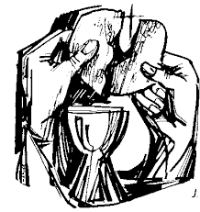
Agnus Dei

All Jesus, Lamb of God,
have mercy on us.

Jesus, bearer of our sins,
have mercy on us.

Jesus, redeemer of the world,
grant us peace.

Giving of Communion

Draw near with faith.
Receive the body of our Lord Jesus Christ
which he gave for you,
and his blood which he shed for you.
Eat and drink
in remembrance that he died for you,
and feed on him in your hearts
by faith with thanksgiving.

All We do not presume,
to come to this your table, O merciful Lord,
trusting in our own righteousness.
but in your manifold and great mercies.
We are not worthy
so much as to gather up the crumbs under your table.
But you are the same Lord
whose nature is always to have mercy.
Grant us therefore, gracious Lord.
so to eat the flesh of your dear Son Jesus Christ
and to drink his blood,
that our sinful bodies may be made clean by his body
and our souls washed through his most precious blood,
and that we may evermore dwell in him, and he in us.
Amen.

All are welcome to receive communion or a blessing.
After receiving each of the bread and the wine please respond “Amen” or, if you would like a blessing, please place your hands across your chest.

Post Communion Hymn Please stand, if able.

Post Communion Prayer
The president leads.

Prayer after Communion

All God of truth,
we have seen with our eyes
and touched with our hands the bread of life:
strengthen our faith
that we may grow in love for you
and for each other;
through Jesus Christ our Lord.
Amen.

or

Father of all,
we give you thanks and praise,
that when we were still far off
you met us in your Son and brought us home.
Dying and living, he declared your love,
gave us grace, and opened the gate of glory.
May we who share Christ’s body live his risen life;
we who drink his cup bring life to others;
we whom the Spirit lights give light to the world.
Keep us firm in the hope you have set before us,
so we and all your children shall be free,
and the whole earth live to praise your name;
through Christ our Lord.
Amen.

Notices and Banns

The Dismissal

Blessing

You are called and loved by God the Father
and kept safe by Jesus Christ.
Mercy, peace and love be yours in abundance,
From God the Father, Son and Holy Spirit.
All Amen. (cf Jude 1,2)

or

May God give to you and to all those you love
his comfort and his peace,
his light and his joy,
in this world and the next;
and the blessing of God almighty,
the Father, the Son, and the Holy Spirit,
be among you and remain with you always.
All Amen.

Deacon Our worship is finished; let our service begin.

Go in peace to love and serve the Lord.
All In the name of Christ, Amen.

Recessional hymn verse

All sing Breathe on me, Breath of God,
till I am wholly thine,
until this earthly part of me
glows with thy fire divine.

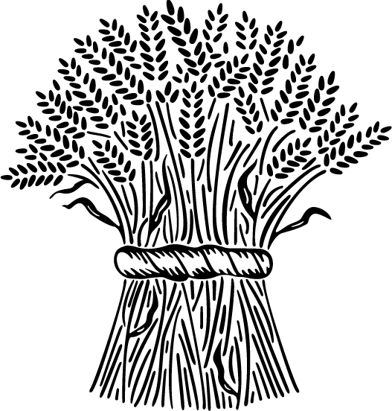

Common Worship: Services and Prayers for the Church of England (2000), and New Patterns for Worship (2002) , material from which is included in this service, is copyright © The Archbishops’ Council. CCL No 908682.
Ordinary Time Booklet 2 St M & AA 2021

